DESIGN PATTERNS AND PRINCIPLES:

Exercise 1: Implementing the Singleton Pattern

Scenario:
You need to ensure that a logging utility class in your application has only one instance throughout the application lifecycle to ensure consistent logging.
Steps:
- Create a New Java Project:
  - Create a new Java project named SingletonPatternExample.
- Define a Singleton Class:
  - Create a class named Logger that has a private static instance of itself.
  - Ensure the constructor of Logger is private.
  - Provide a public static method to get the instance of the Logger class.
- Implement the Singleton Pattern:
  - Write code to ensure that the Logger class follows the Singleton design pattern.
- Test the Singleton Implementation:
  - Create a test class to verify that only one instance of Logger is created and used across the application.

CODE:
Logger.java
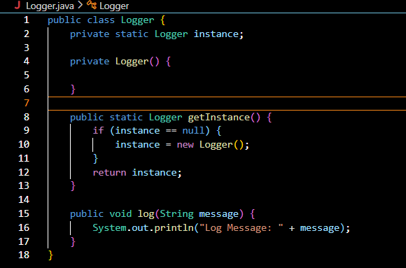
Main.java
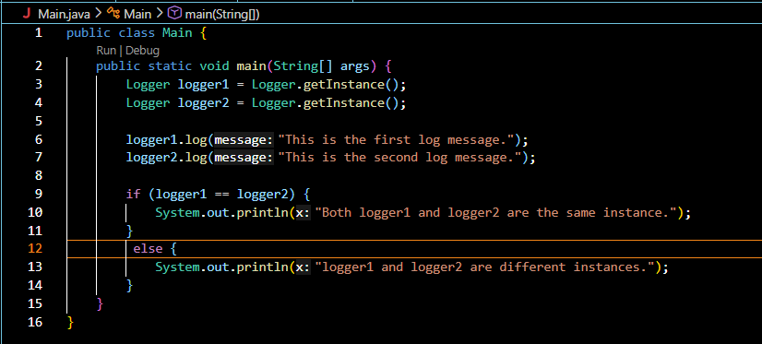
OUTPUT:
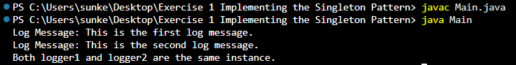

Exercise 2: Implementing the Factory Method Pattern
Scenario:
You are developing a document management system that needs to create different types of documents (e.g., Word, PDF, Excel). Use the Factory Method Pattern to achieve this.
Steps:
- Create a New Java Project:
  - Create a new Java project named FactoryMethodPatternExample.
- Define Document Classes:
  - Create interfaces or abstract classes for different document types such as WordDocument, PdfDocument, and ExcelDocument.
- Create Concrete Document Classes:
  - Implement concrete classes for each document type that implements or extends the above interfaces or abstract classes.
- Implement the Factory Method:
  - Create an abstract class DocumentFactory with a method createDocument().
  - Create concrete factory classes for each document type that extends DocumentFactory and implements the createDocument() method.
- Test the Factory Method Implementation:
  - Create a test class to demonstrate the creation of different document types using the factory method.

CODE:
Document.java
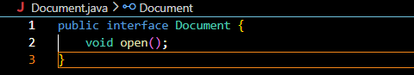
ExcelDocument.java
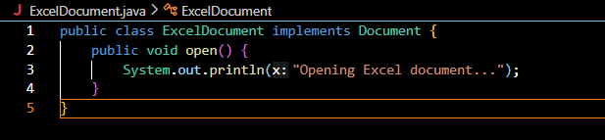
PdfDocument.java
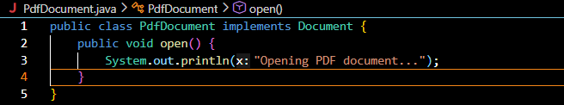
WordDocument.java
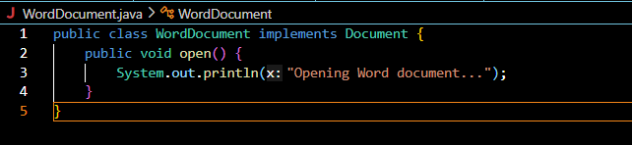

DocumentFactory.java
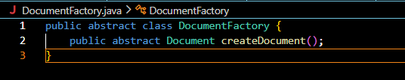
ExcelDocumentFactory.java
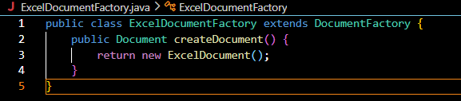
PdfDocumentFactory.java
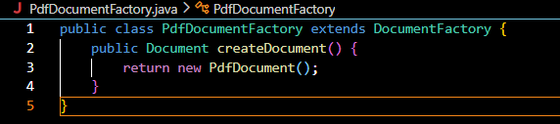
WordDocumentFactory.java
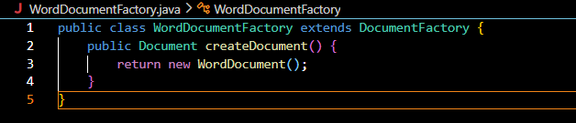

Main.java
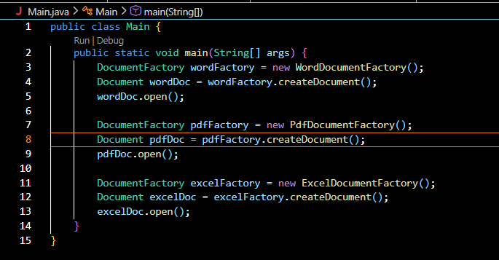

OUTPUT:
